|  |  |  |
| --- | --- | --- |
| **Project Design Document** | |  | | --- | | *10/18/2025*  Happy Tony | |

|  |  |  |  |
| --- | --- | --- | --- |
| **Project Concept** | | | |
| **1** **Player Control** |  | You control a   |  | | --- | | *Tank* | | in this   |  |  | | --- | --- | | *isometric* | game | |
|  | where   |  | | --- | | *Space bar* | | makes the player   |  | | --- | | *To shoot and left and right arrow moves* | |

|  |  |  |  |  |  |  |
| --- | --- | --- | --- | --- | --- | --- |
| **2** **Basic**  **Gameplay** |  | During the game,   |  |  | | --- | --- | | *Enemy* | appear | | from   |  | | --- | | *the front side* | |
|  | and the goal of the game is to   |  | | --- | | *Shoot the enemies and protect the border lines* | | |

|  |  |  |  |  |  |
| --- | --- | --- | --- | --- | --- |
| **3** **Sound**  **& Effects** |  | There will be sound effects   |  | | --- | | *For the shooting, when the enemy tank collides with the shell, when the Enemy collide with Player* | | and particle effects   |  | | --- | | *For the shooting, Enemy explosion, Player Explosion (Game Over)* | |
|  | [*optional*] There will also be   |  | | --- | | *Background music during the game, there will be more enemy types (Tanks, Human)* | | |

|  |  |  |  |  |  |
| --- | --- | --- | --- | --- | --- |
| **4** **Gameplay**  **Mechanics** |  | As the game progresses,   |  | | --- | | *The difficulty level increases* | | making it   |  | | --- | | *More enemy objects are spawn* | |
|  | [*optional*] There will also be   |  | | --- | | *Speed of the game increases* | | |

|  |  |  |  |  |  |  |  |
| --- | --- | --- | --- | --- | --- | --- | --- |
| **5** **User**  **Interface** |  | The   |  | | --- | | *Scores* | | will   |  | | --- | | *Increases* | | whenever   |  | | --- | | *Based on destroying the enemies* | |
|  | At the start of the game, the title   |  |  | | --- | --- | | *Behind the enemy lines* | will appear | | | and the game will end when   |  | | --- | | *When one enemy come inside* | |

|  |  |  |  |
| --- | --- | --- | --- |
| **6** **Other Features** |  | |  | | --- | | *There is a slider to choose the difficulty level for the player. Game restart is possible at any point of time. Game can be paused using Esc Key.* | |

# **Project Timeline**

|  |  |  |
| --- | --- | --- |
| **Milestone** | **Description** | **Due** |
| **#1** | |  | | --- | | * *Prepare the Project Design Document #1* | | |  | | --- | | *10/13* | |
| **#2** | |  | | --- | | * *Basic Gameplay #2* | | |  | | --- | | *10/14* | |
| **#3** | |  | | --- | | * *Sound and Effects #3* | | |  | | --- | | *10/15* | |
| **#4** | |  | | --- | | * *Gameplay Mechanics #4* | | |  | | --- | | *10/16* | |
| **#5** | |  | | --- | | * *User Interface #5* | | |  | | --- | | *10/16* | |
| **Backlog** | |  | | --- | | * *Implementation of improvements from User Testing 1* * *Implementation of improvements from wider User Feedback 1* * *Implementation of improvements from wider User Feedback 1* | | |  | | --- | | *10/31* | |

# **Project Sketch**

The Game Mechanics can be summarized as below

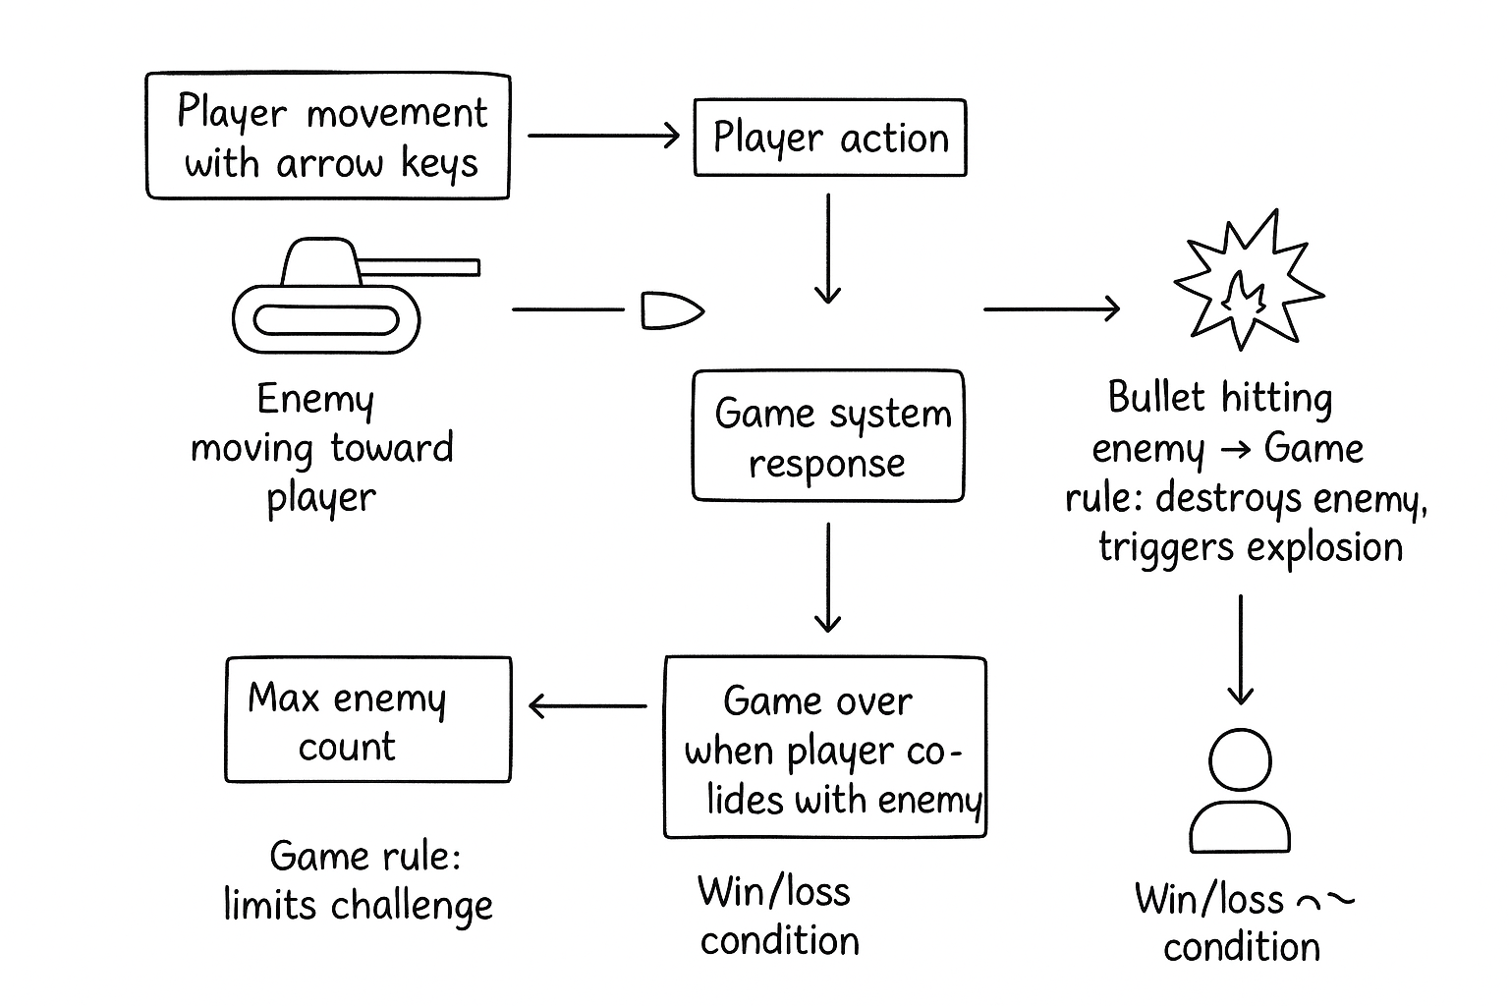

The UI look can be as below

